TASKS ON BASH SCRIPTING
- Create a bash script to check if a directory is available or not
Outcome : checks for directory is available or not
Objective : to check if a directory is available or not
Step by step manner:
- Create a file with a sh extension
- Edit the file with the desired script
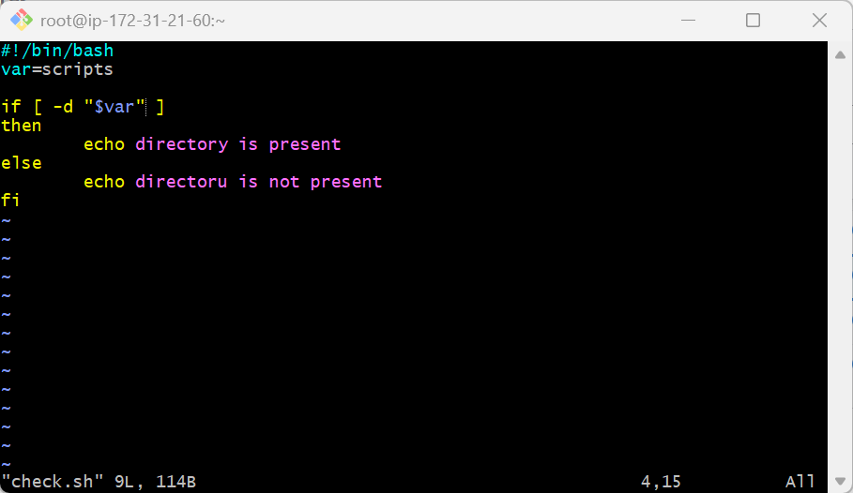
- Then change the permissions and with the commands chmod
- Run the command ./check.sh or bash check.sh

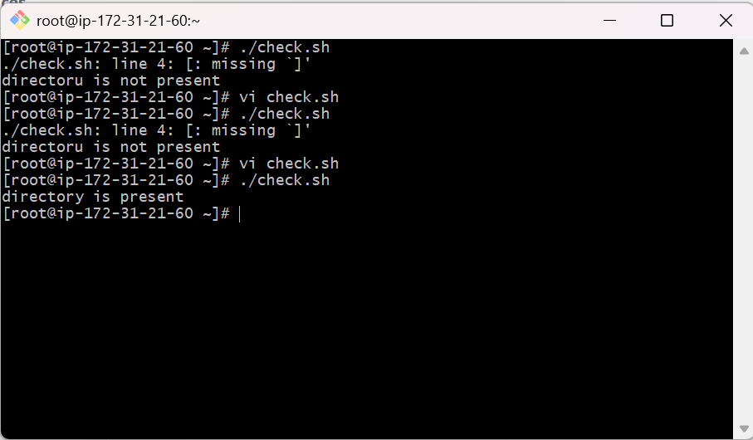

- Create a bash script to create multiple files.
Outcome: multiple files will be created
Objective: to create multiple file by using scripts
Step by step manner:
- Create a file with .sh extension to identify which we are using
- Edit the file with the script
- 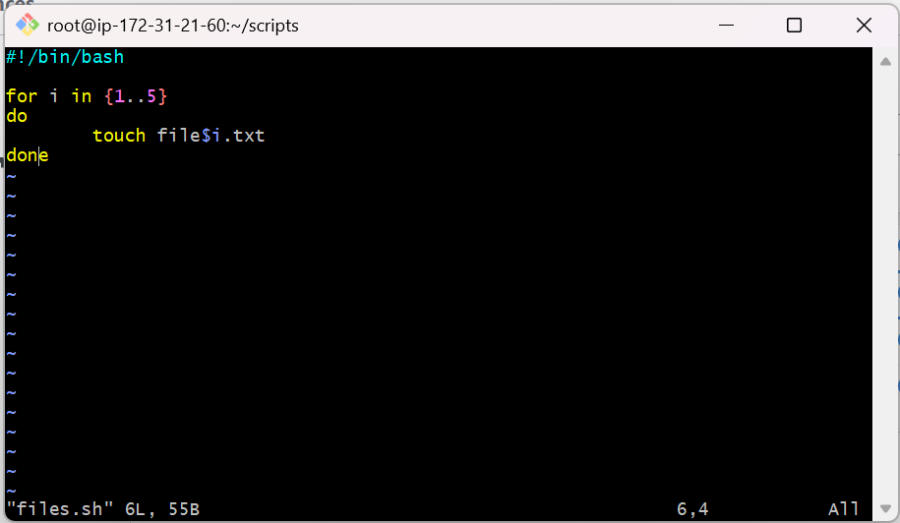
- Change the permissions by using command -> chmod 755 files.sh
- Run the command ./files.sh to get the output of the script
- 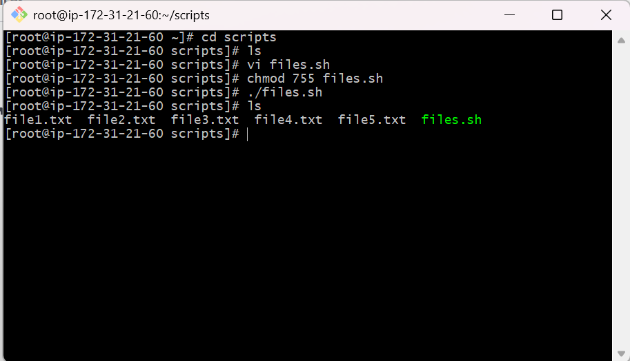
- Create a bash script to take a backup of a directory
Output: backup of a directory is created
Objective: to create a backup of a directory
Step by step implementation:
- Create a file with .sh extension
- Edit the script in the file by using vi filename.sh
- 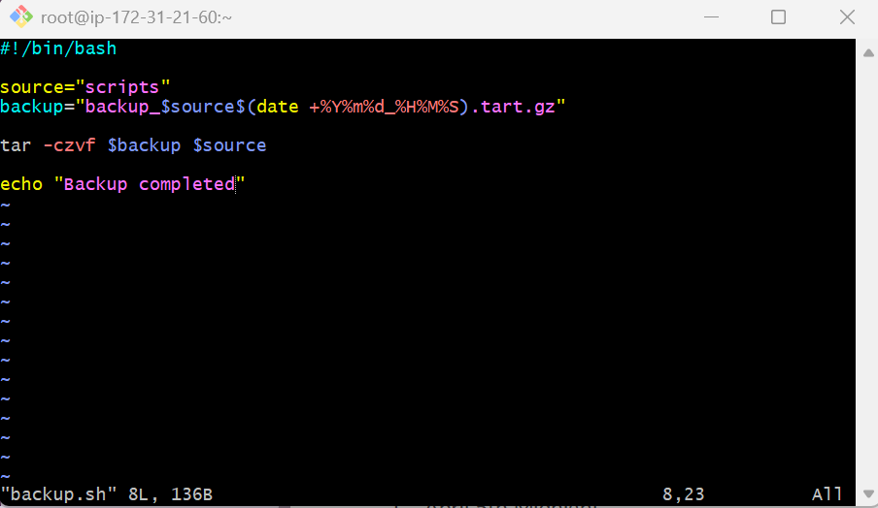
- Change the permissions with command chmod
- Run the command ./backup.sh to get the output
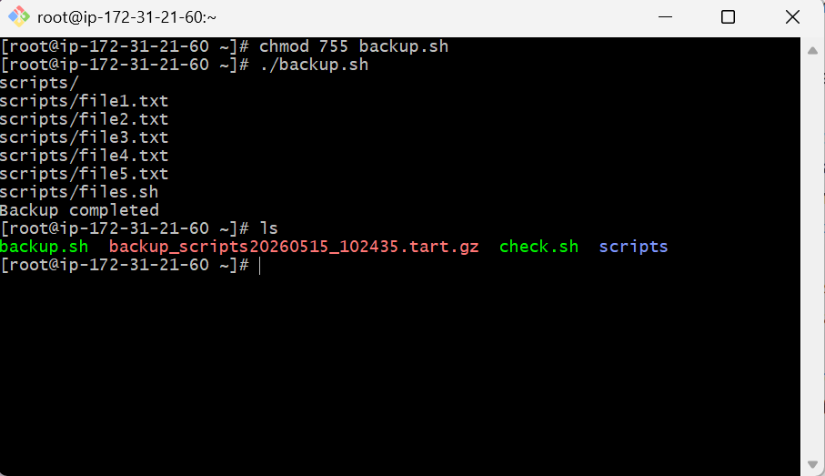

- Create a bash script to install nginx on an EC2 server
Outcome: nginx is installed
Objective: to install a nginx on an ec2 server by using the bash script
Step by step manner:
- Create a file with .sh extension
- Edit the file with the desired script
- 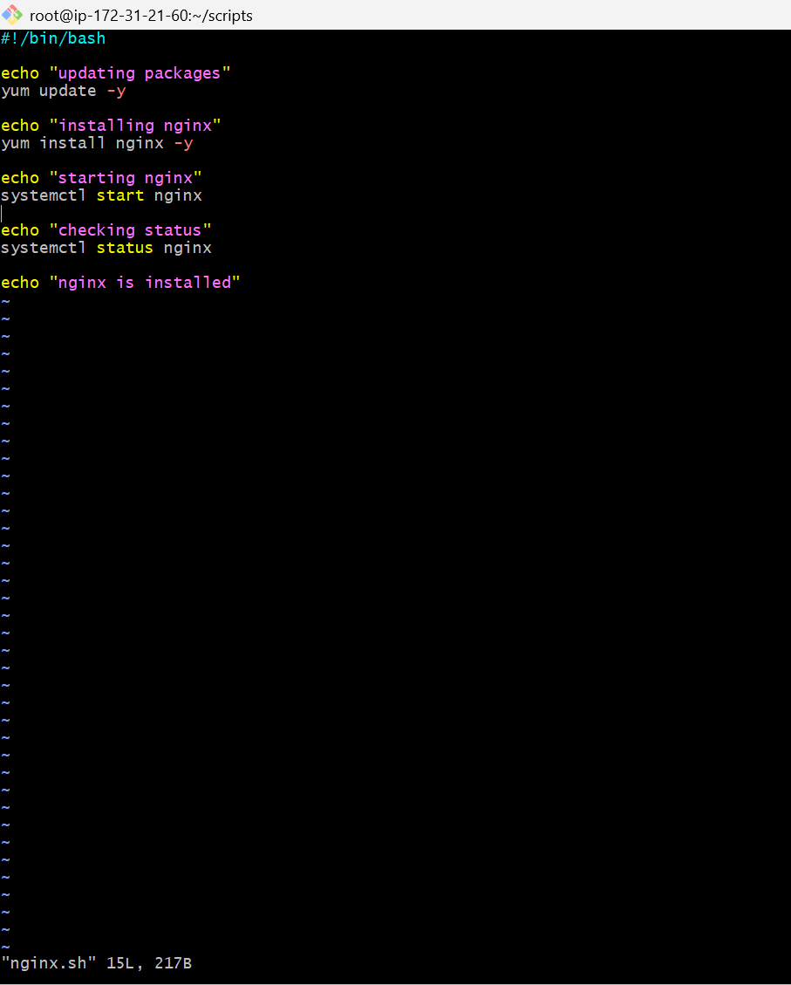
- Change the permissions by the command chmod
- Run command ./nginx.sh to install the nginx

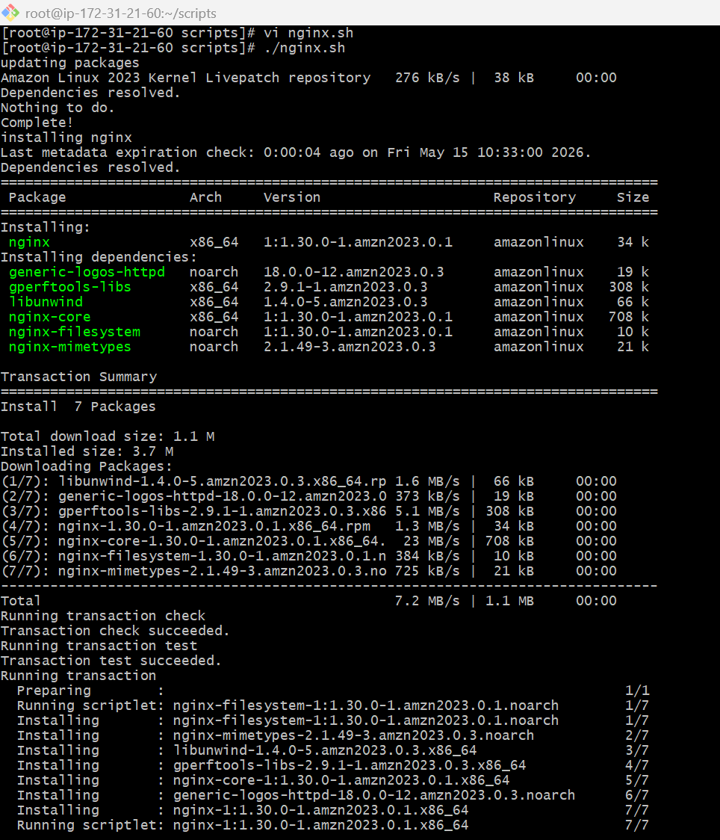
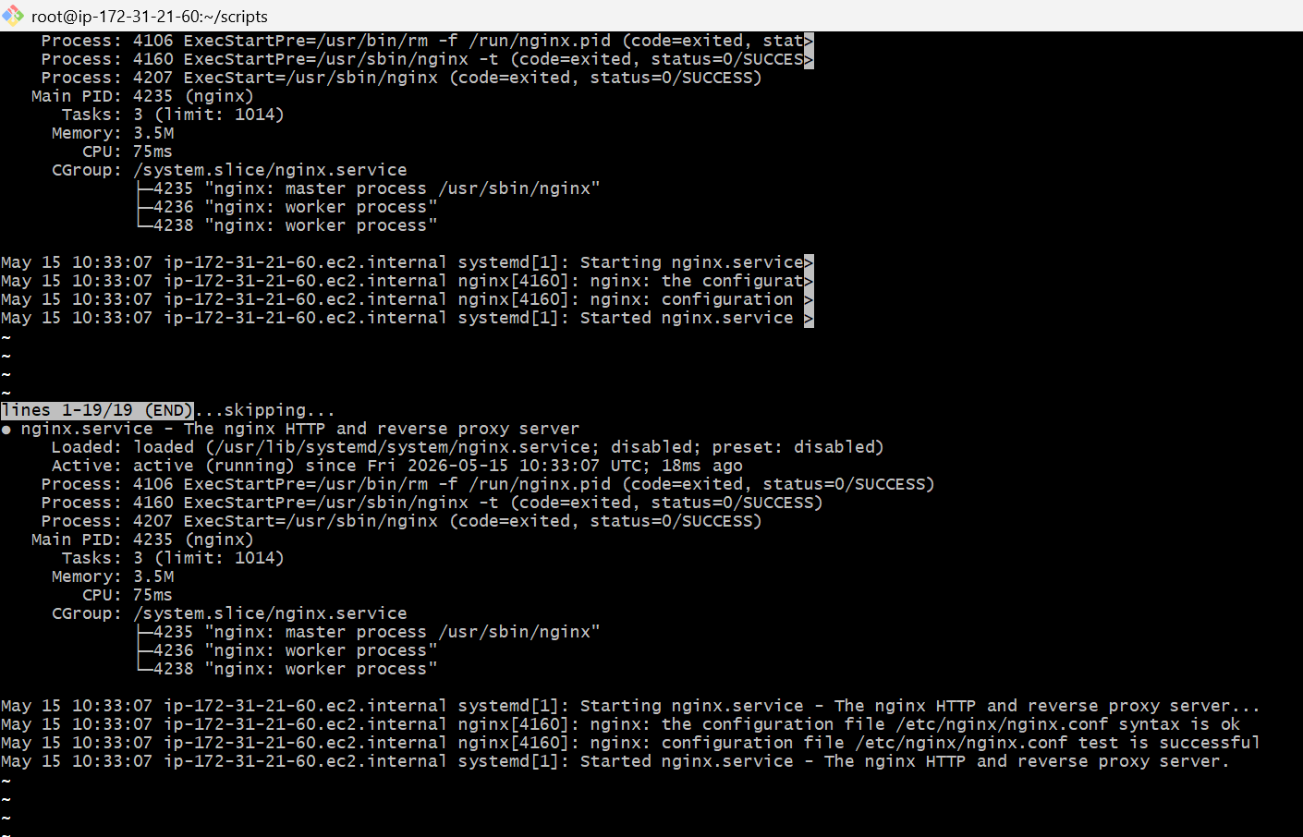
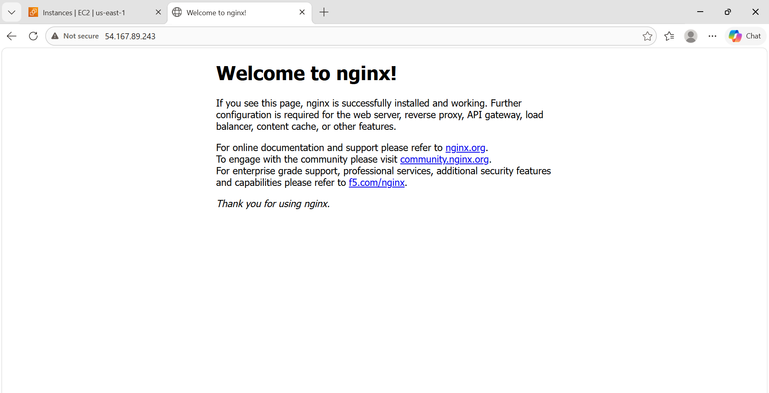

- Create a bash script to install apache tomcat on an ec2 server
Outcome: apache tomcat is installed successfully
Objective: to install apache tomcat on an ec2 server
Step by step implementation:
- Create a file with .sh extension
- Edit the file with desired script
- 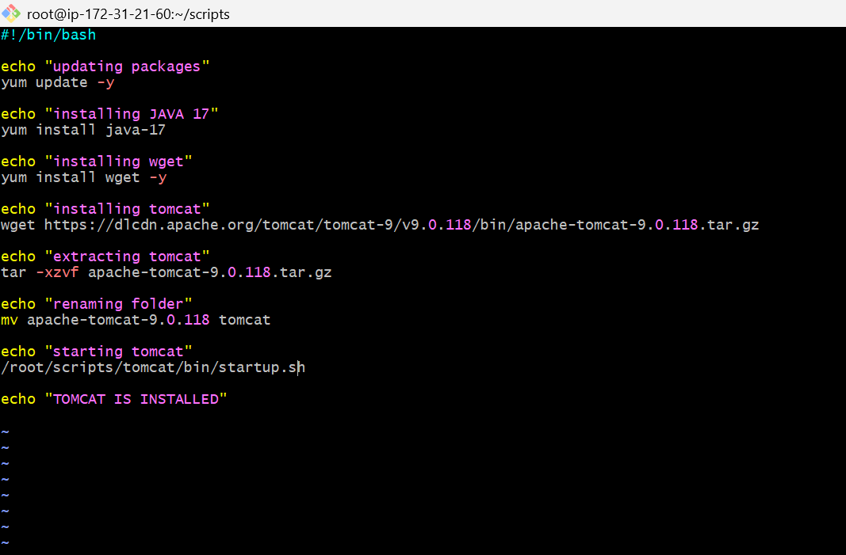
- Change the permissions by chmod command
- Run command ./tomcat.sh to install tomcat
- 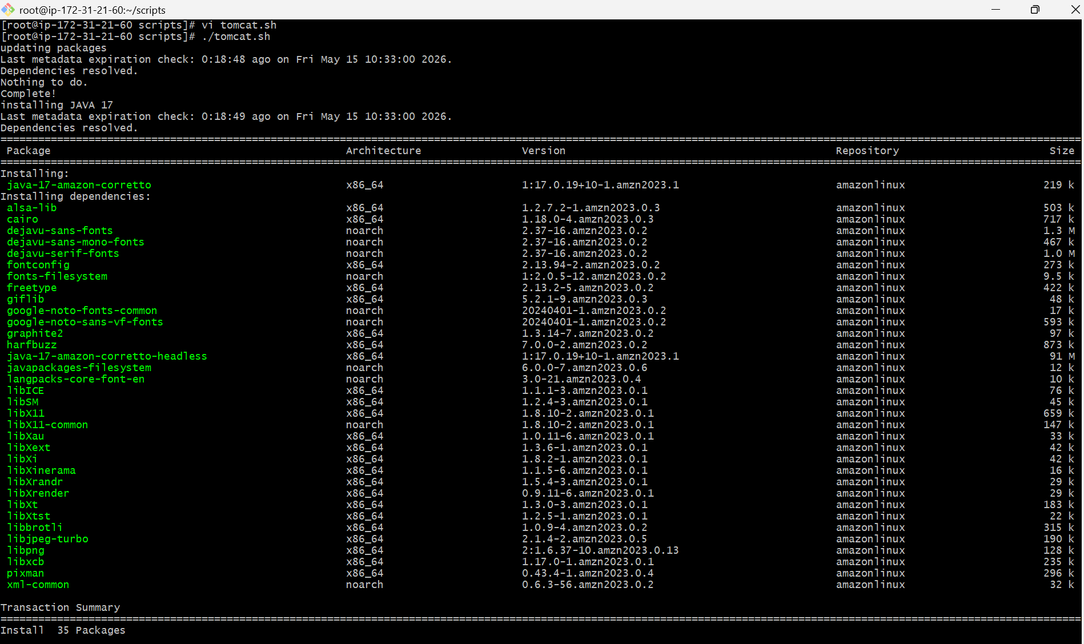
- 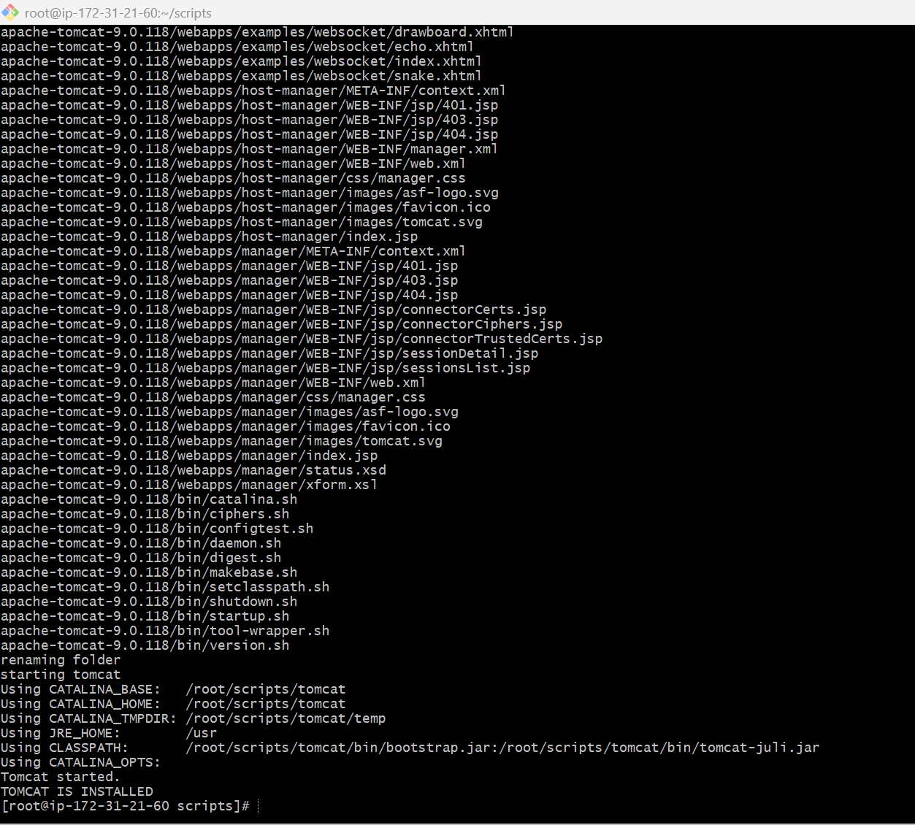
- 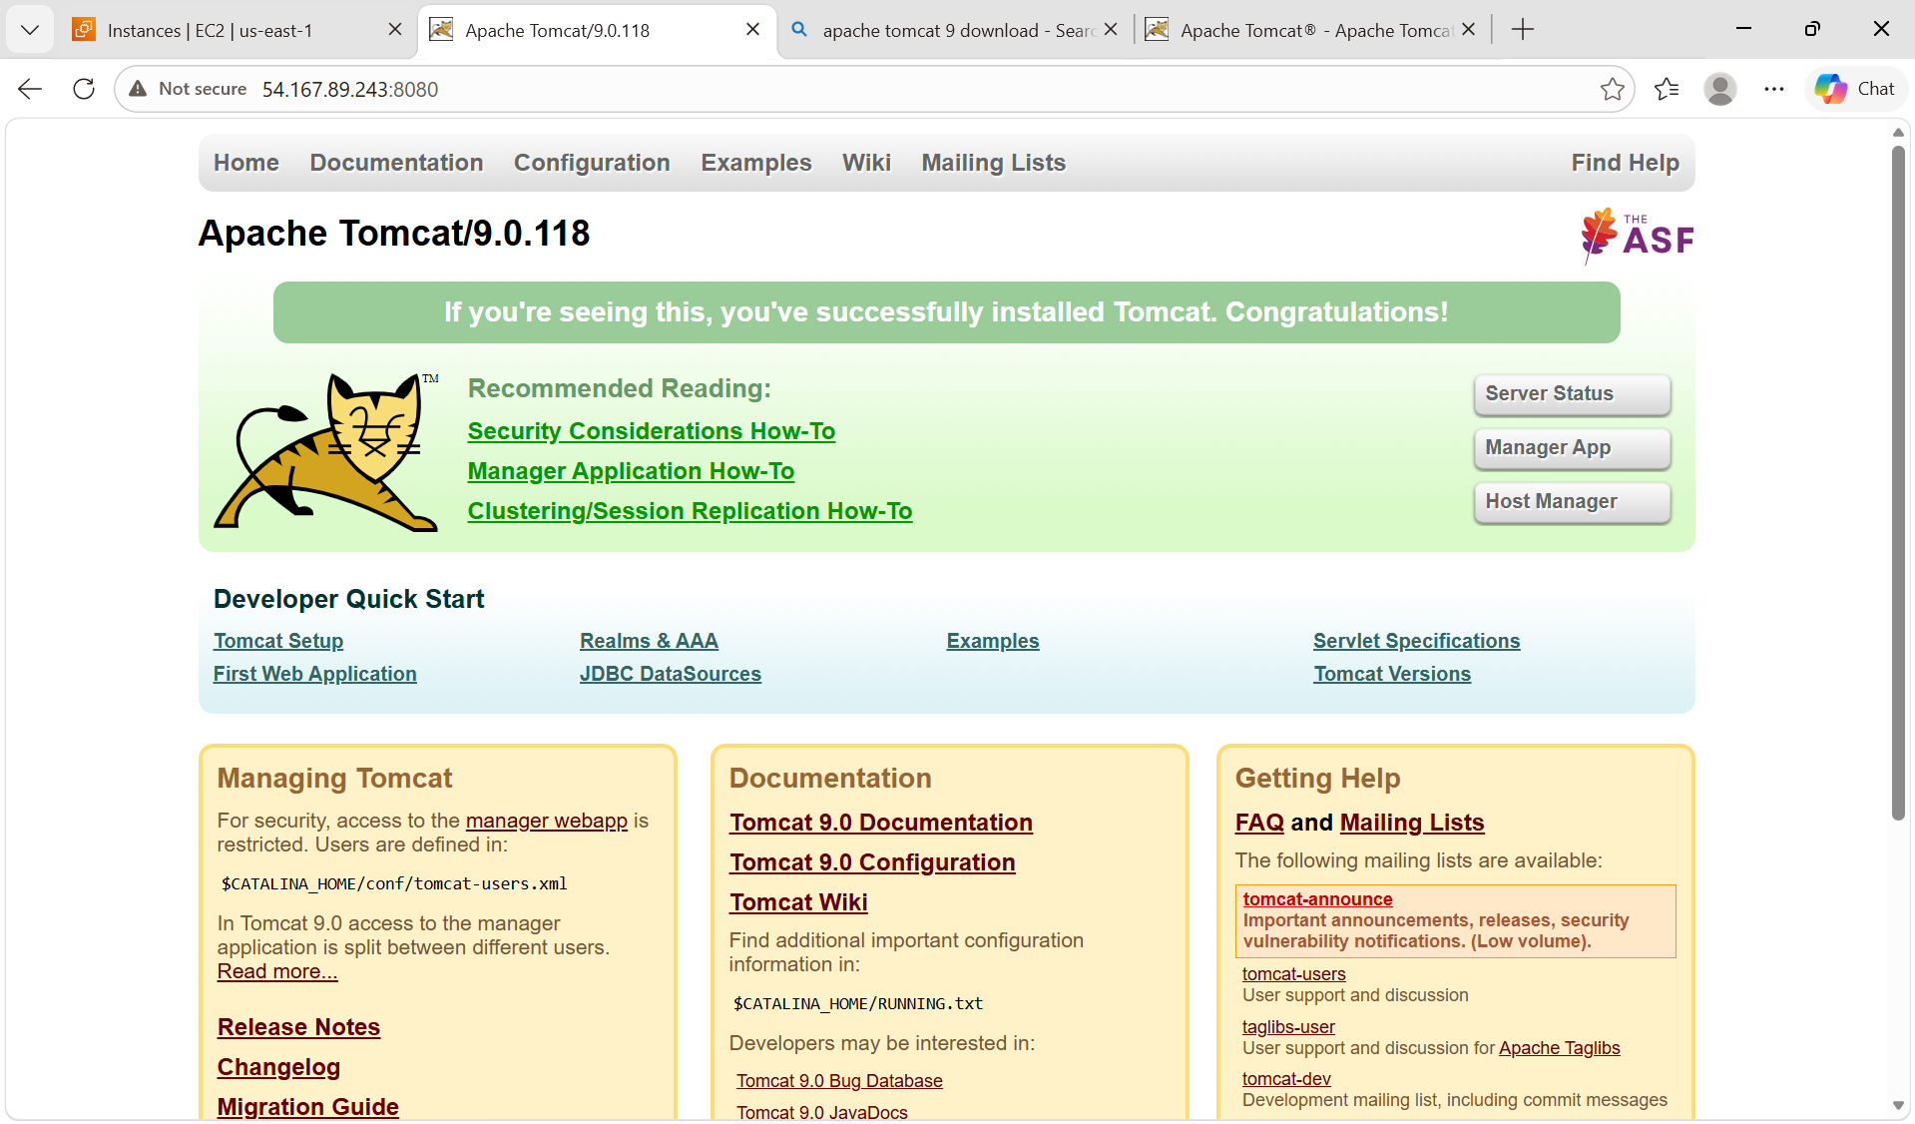
- Create a bash script to check if the nginx service is running, if not running then script should start the service
Outcome: nginx service is running
Objective: to check if the service is running, if not run the service by the script
Step by step implementation:
- Create a file with .sh extension
- Edit the file with desired script
- 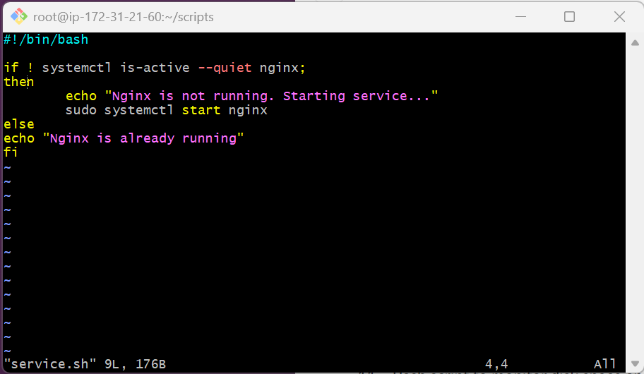
- Change the permissions with chmod command
- Run the command ./service.sh to get the output
- 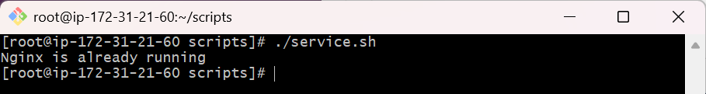
- Create a bash script for a calculator
Outcome: calculator
Objective: to create a calculator
Step by step manner:
- Create a file with .sh extension
- Edit the file with desired script
- 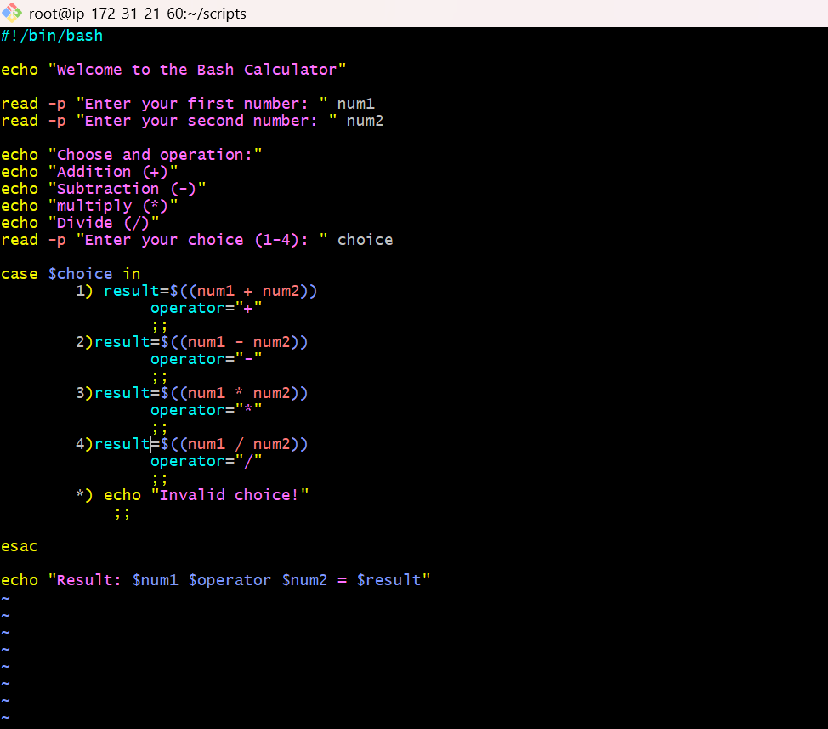
- Change the permissions with chmod command
- Run the command ./calculator.sh to get the ouput
- 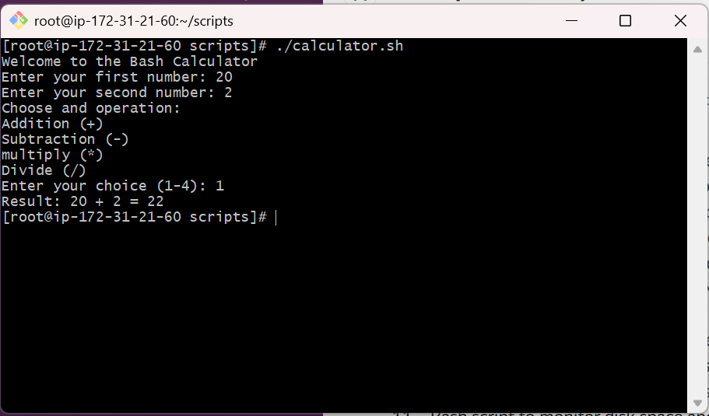

8.create a bash script to delete the last 3 lines of a file
Outcome: last 3 lines were deleted
Objective: to delete the last 3 lines of a file
Step by step manner:
- Create a file with .sh extension
- Edit the file with desired script
- 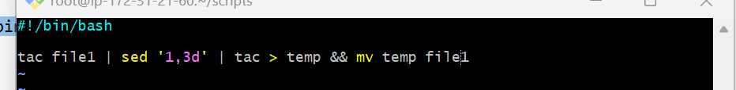
- Change the permissions of file with chmod command
- Run the command ./lines.sh to get the output
- 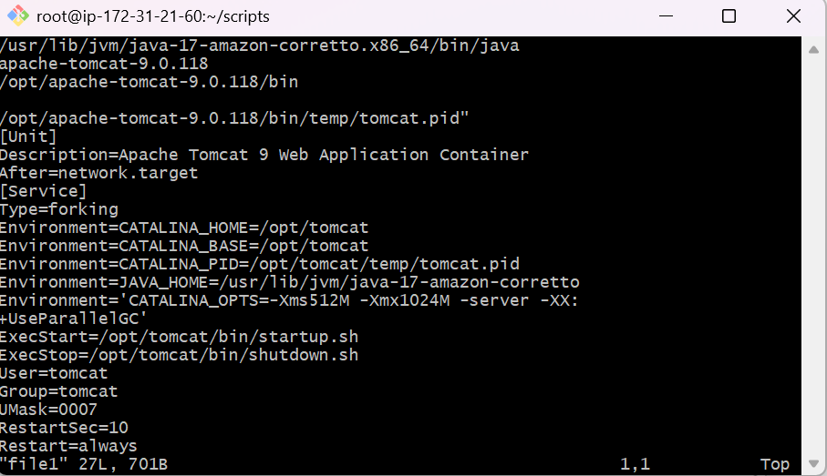
10. Bash script to monitor cpu and if it is more then 80% then send email notification
Outcome: if the threshold value is > 80% then email will be sent to the given mailid
Objective: to monitor cpu
Step by step manner:
- Create a file with .sh extension
- Edit the file with desired script
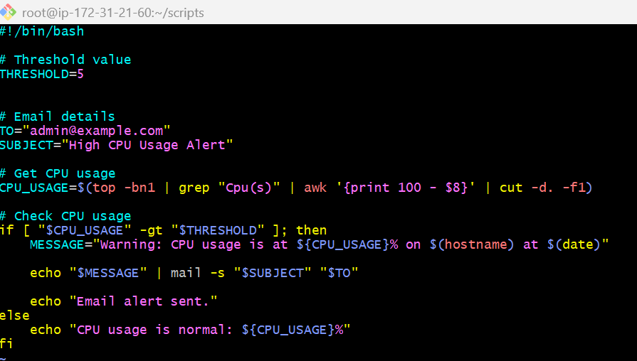
- Change the permission with chmod command
- Run ./monitor.sh command to get the output

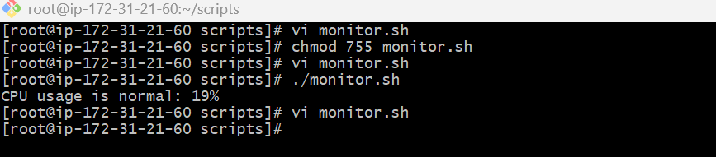

11. Bash script to monitor disk space and if it is more then 80% then send email notification
Outcome: email is sent
Objective : to monitor disk space and send email
Step by step implementation:
- Create a file with .sh extension
- Edit the file with desired script
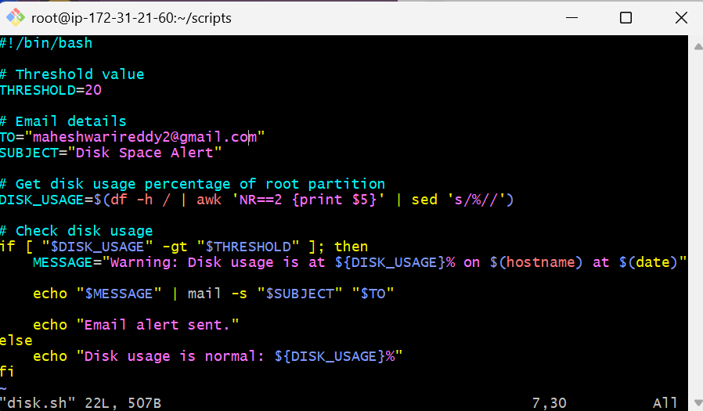
- Change the permissions with chmod command
- Run the command ./disk.sh to get the outcome
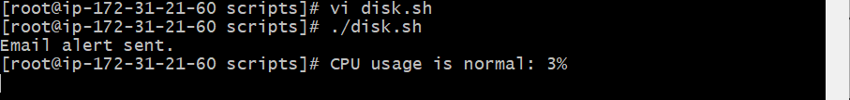

12. Bash script to monitor memory and if it is more than 80% then send email notification
Outcome: sents a email that memory is 80% full
Objective: to sent a mail that your memory is more than 80% usage
Step by step implementation:
- create a file with .sh extension
- edit the file with desired script
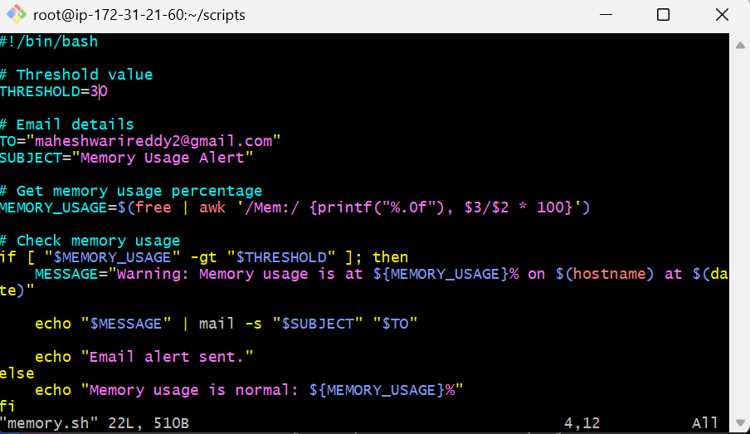
- change the permissions with chmod command
- run the command ./memory.sh to get the outcome

CRONJOBS
- to set a specific job at a specified time that we have to give.
